# EduConnect : Smart Learning and Enrollment CRM Portal

**Goal:**

The goal of this project is to build a Salesforce-based Student Enrollment and Learning Portal that automates the complete admission process. It will streamline student inquiries, course enrollments, and fee tracking while reducing manual effort and delays. Automated notifications and reminders will improve communication with students and faculty. Overall, the system will enhance efficiency, accuracy, and reporting, ensuring a smoother enrollment experience for educational institutes.

**Problem Statement:**

Educational institutes face challenges in managing student inquiries, admissions, and course enrollments due to manual processes. This causes delays, missed follow-ups, and inefficiency. A Salesforce-based portal will automate lead capture, admissions, fee tracking, and notifications, ensuring faster enrollment and better reporting.

# Phase 4: Process Automation (Admin)

## Phase 4 focuses on **Process Automation** within Salesforce. In this phase, different automation tools such as Validation Rules, Workflow Rules, Approval Processes, Email Alerts, and Field Updates were implemented to streamline the **admission and enrollment process** for the Smart Student Enrollment and Learning Portal.

## Validation Rules

Validation rules were created to ensure data accuracy and integrity:

* Prevented negative values in the **Course Fees** field.
* Enforced correct format for **Email IDs** of students and teachers.
* Ensured **Batch Start Date** is always earlier than **End Date**.

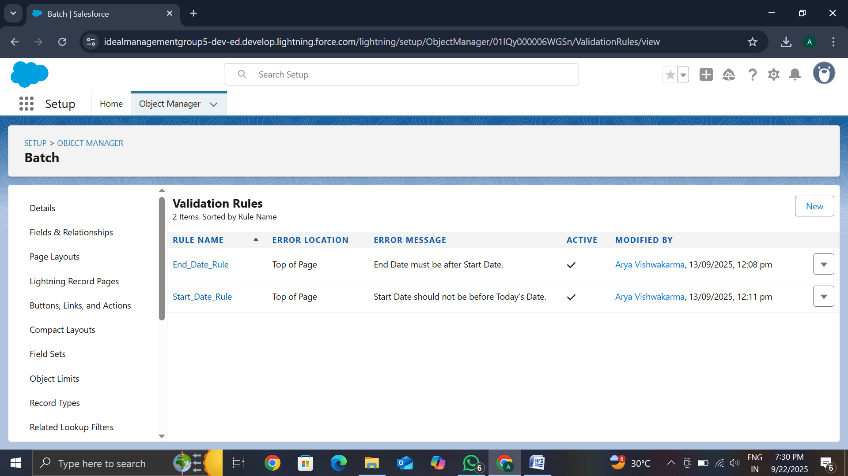

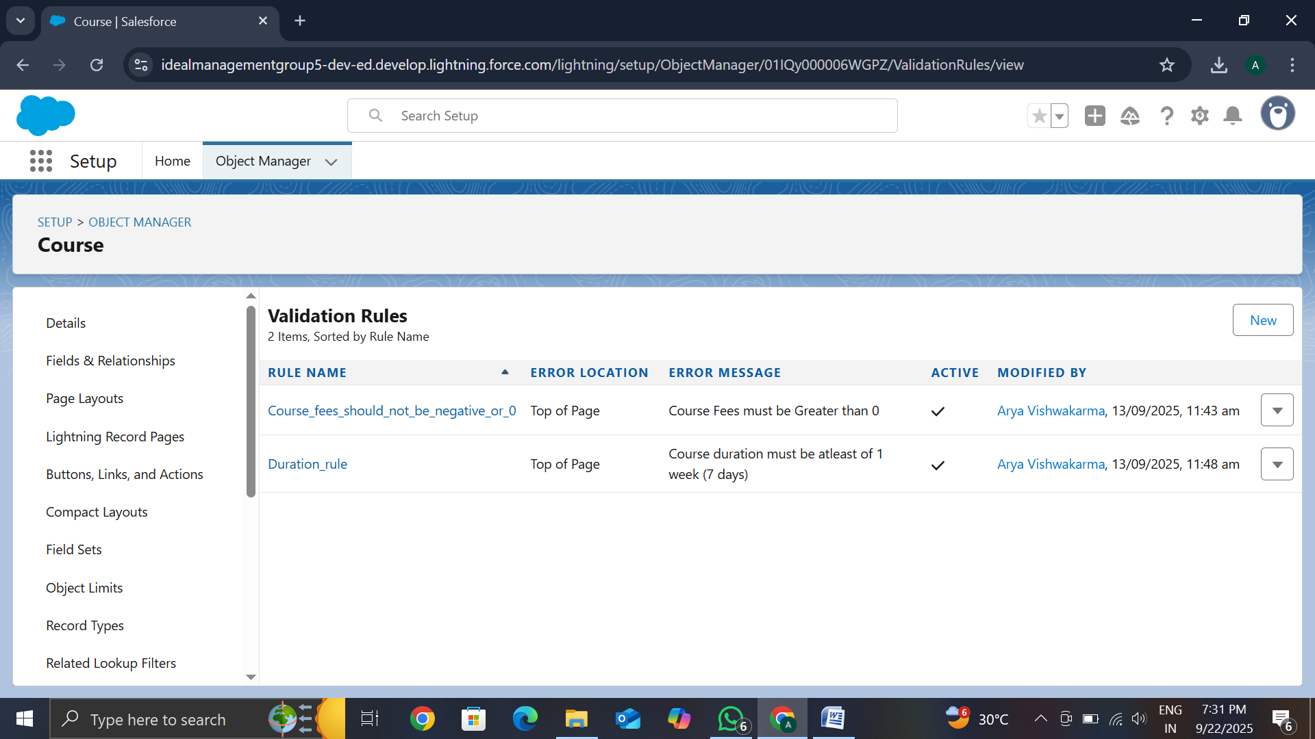

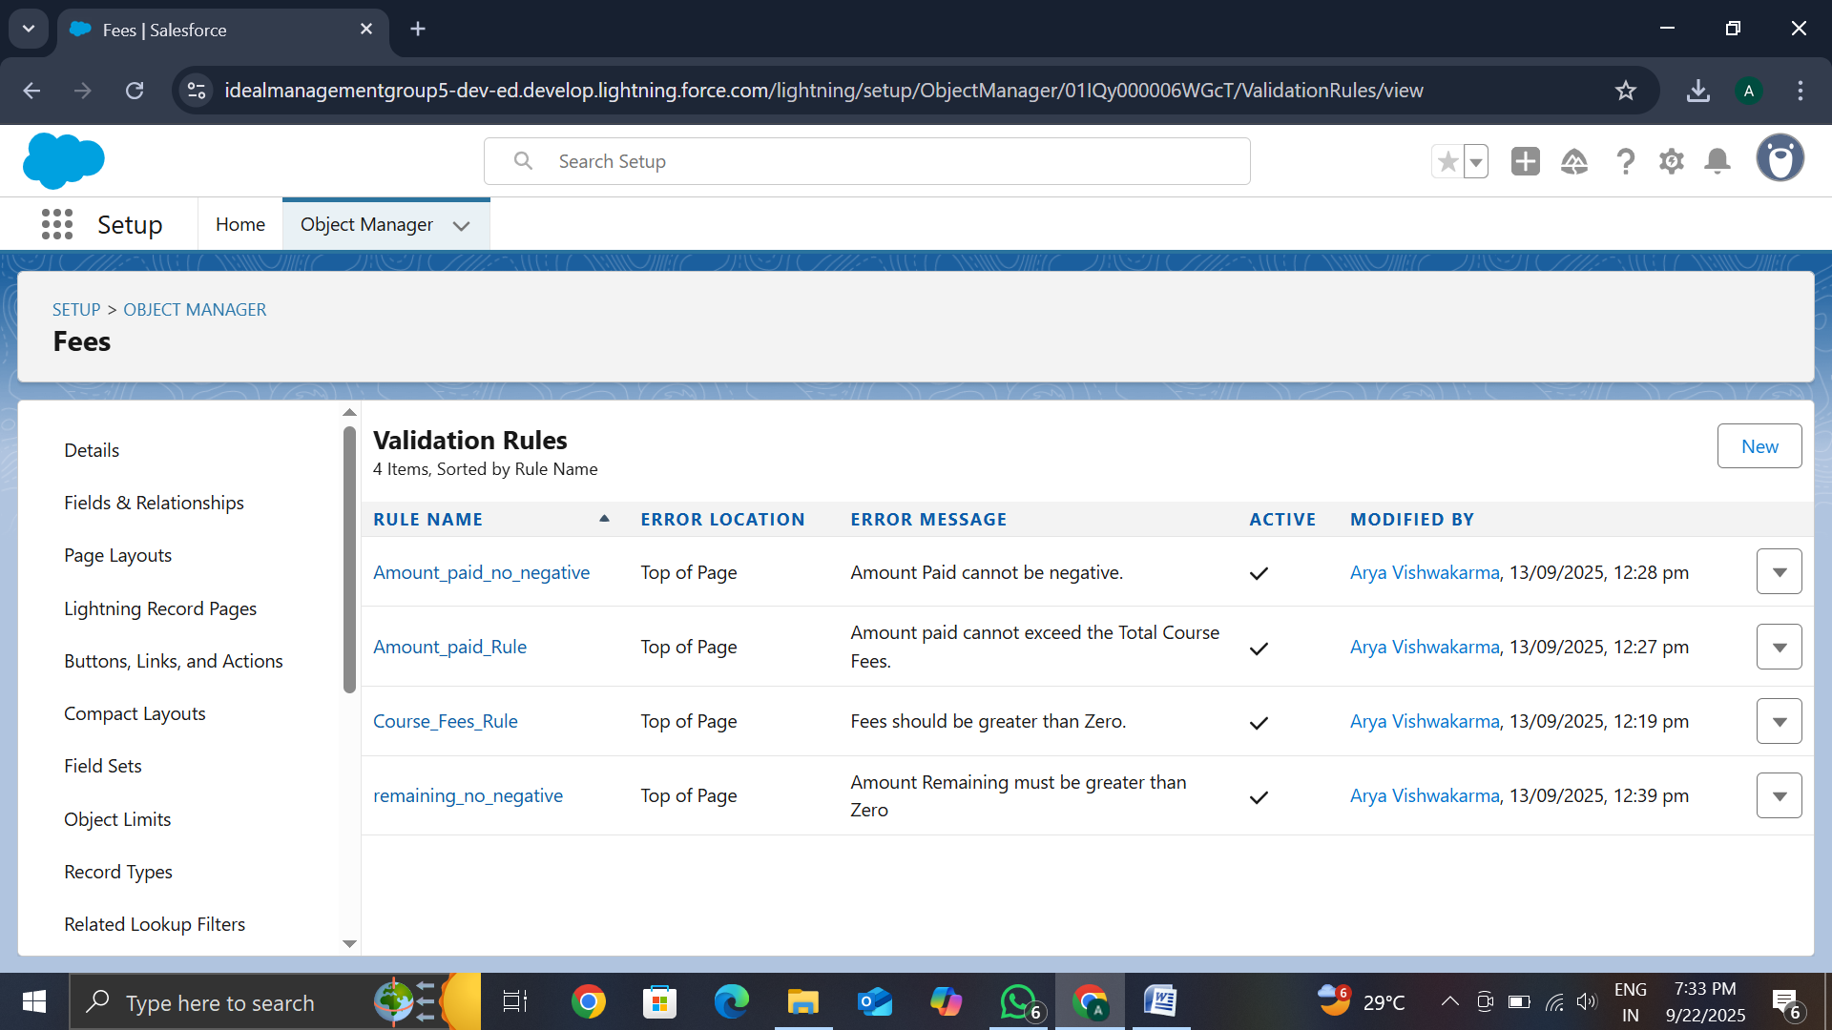

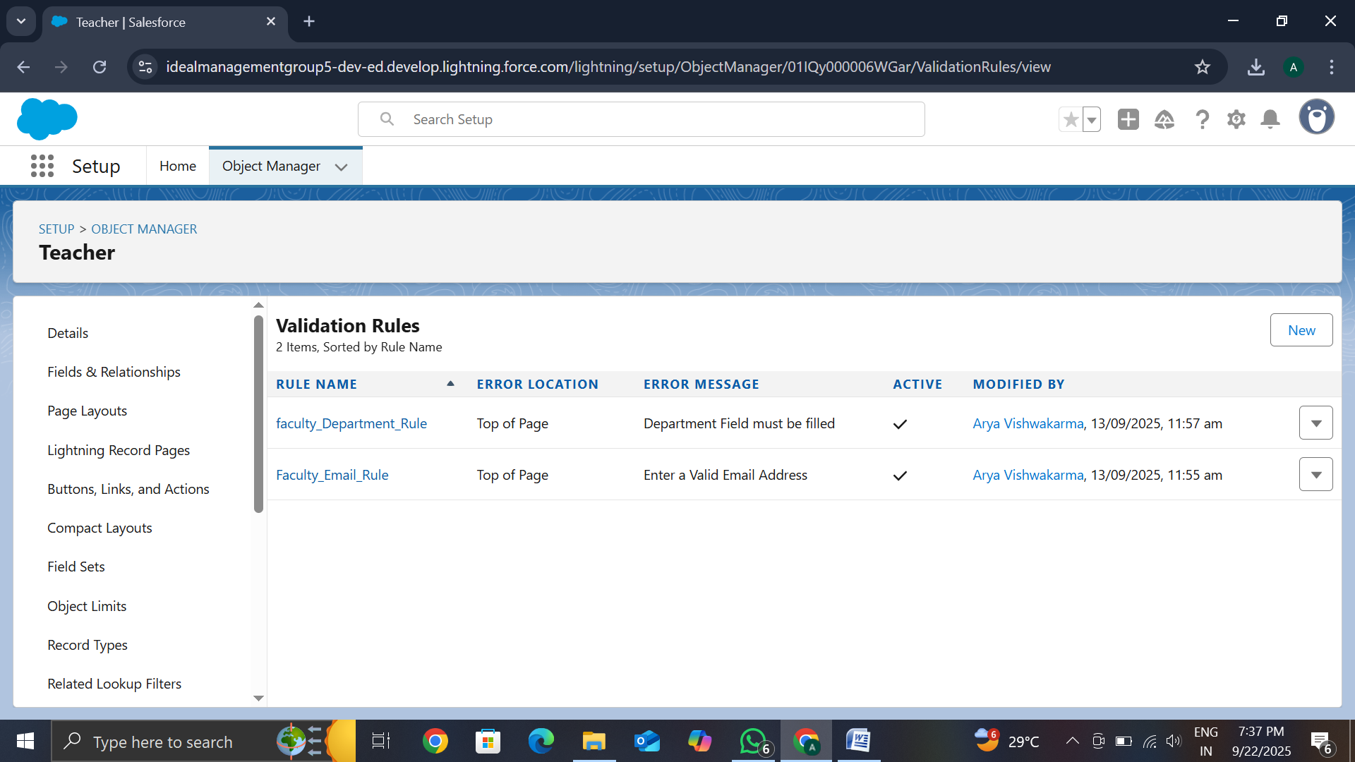

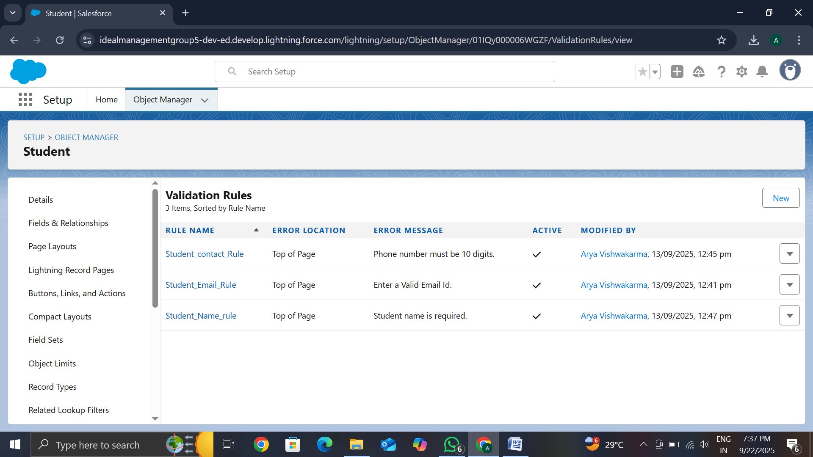

## ****Workflow Rules****

Workflow rules were set up to automate repetitive tasks:

* Triggered automatic **email alerts** when a student’s admission was confirmed.
* Sent **fee payment reminders** before due dates.
* Updated specific fields (such as status) based on admission or enrollment actions.

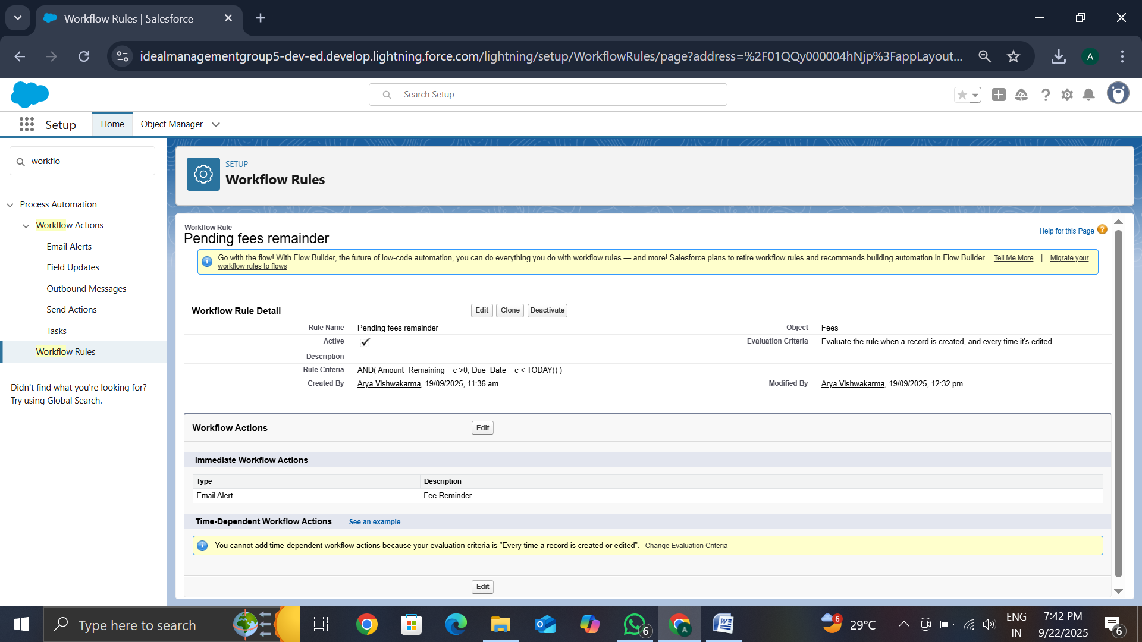

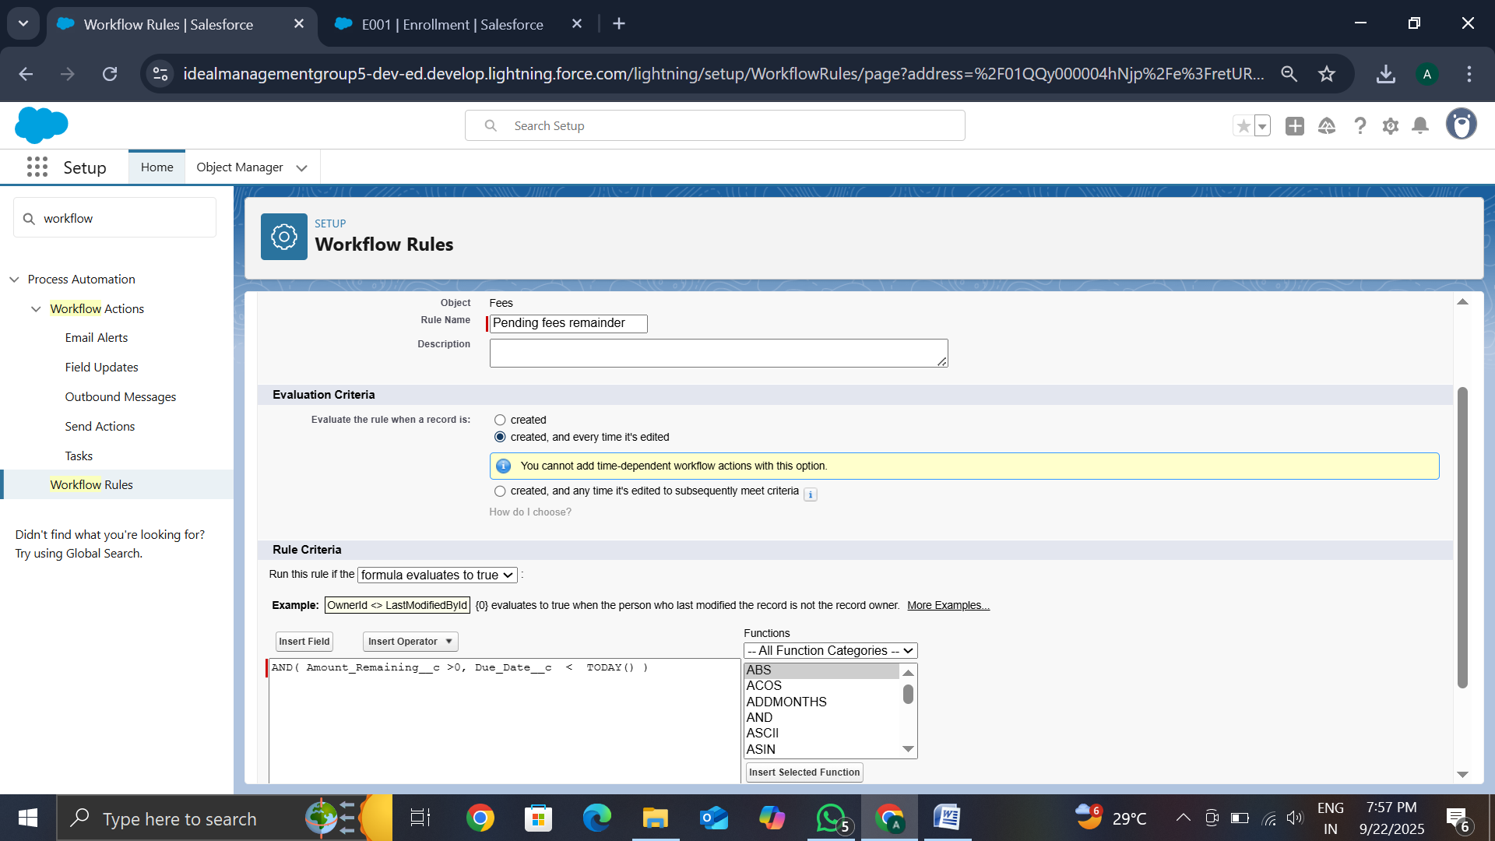

## ****Approval Process****

An **Approval Process** was created for scholarship-based admissions:

* Student applications requesting scholarships were routed for approval.
* Only after approval, the scholarship was applied to the student’s fee record.
* This ensured proper authorization and transparency.

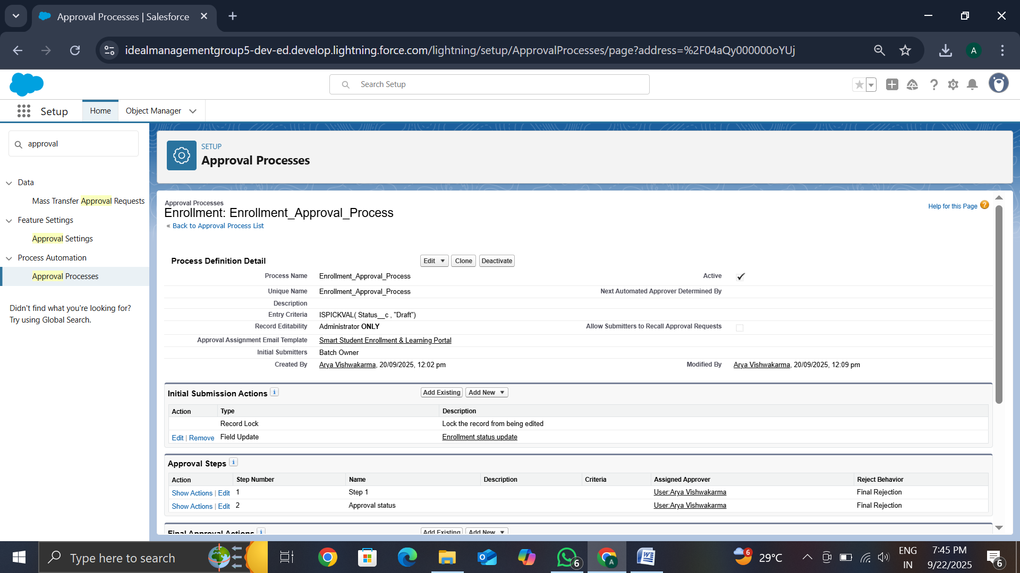

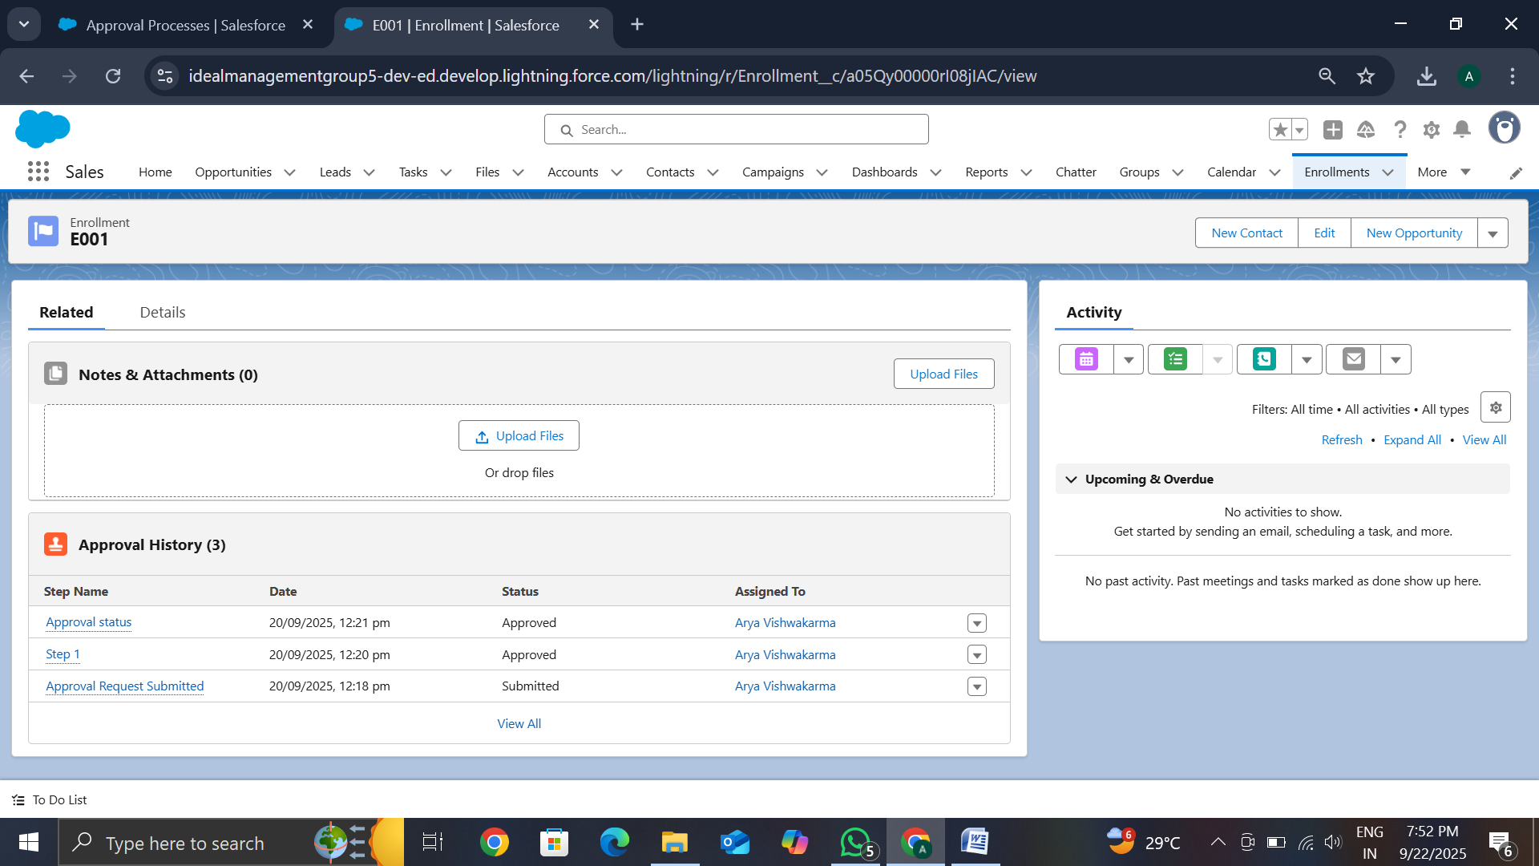

## ****Email Alerts****

Email alerts were used to improve communication between students, faculty, and administrators:

* Admission confirmation emails were sent automatically after successful enrollment.
* Faculty members received notifications when students enrolled in their courses.
* Fee payment reminder emails were triggered before the due date.

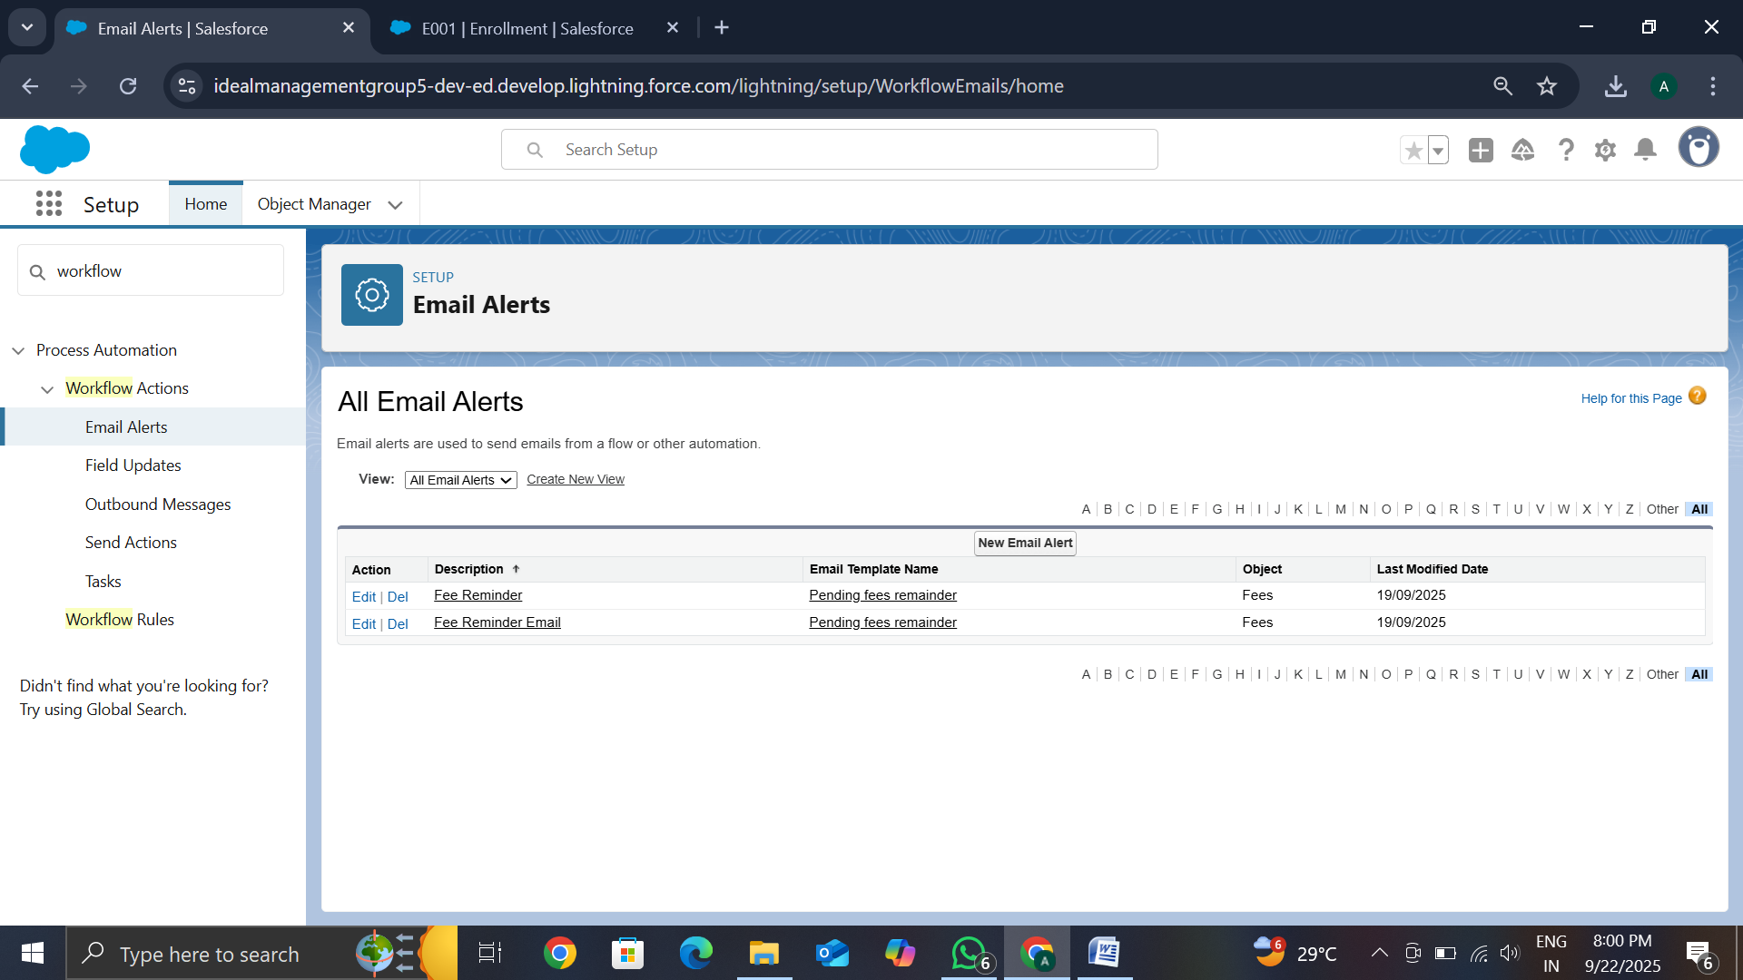

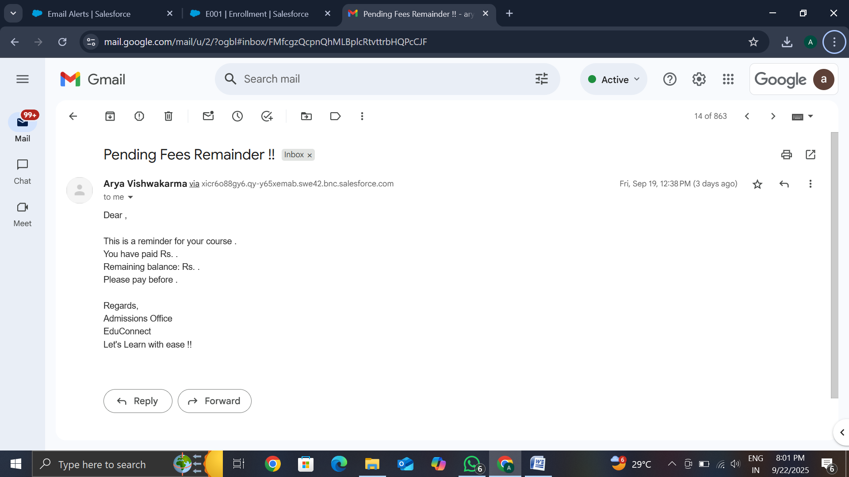

## ****Field Updates****

Field updates ensured records remained accurate and up-to-date:

* Automatically updated **Enrollment Status** to “Enrolled” after fee confirmation.
* Updated **Payment Status** fields when students made partial or full payments.
* Adjusted **Remaining Fee Amount** field dynamically during fee transactions.

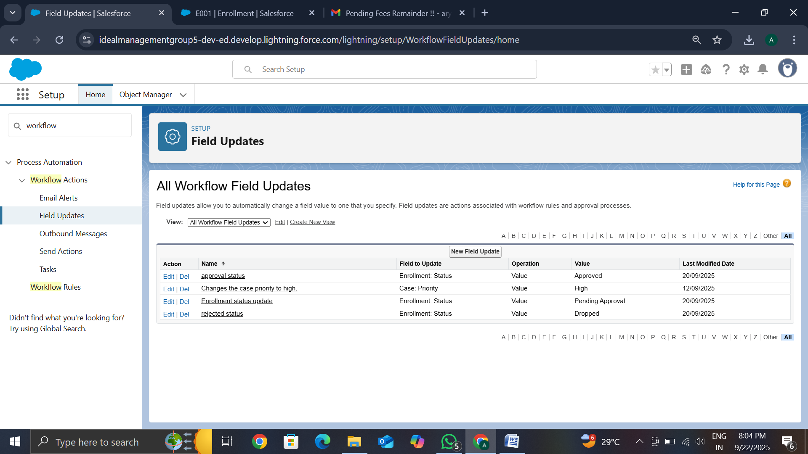

## ****Conclusion****

Phase 4 successfully automated the admission and enrollment process. With validation rules ensuring data accuracy, workflow rules reducing manual effort, approval processes streamlining scholarship applications, email alerts improving communication, and field updates maintaining accurate records, this phase enhanced **efficiency, accuracy, and reliability** of the CRM portal.